**NYASHA SIMANGO H150319N LAB ASSGNMENT**

**Lab Assignment:**

**Aim**

Write a Python function that takes a list of words and returns the length of the longest one.

**Methodology:**

Using Jupyter Notebook python version 2.7:

1. Click File and Create a new file
2. Write code to download natural language toolkit that is **nltk.download()**
3. Create a new file
4. Write the code to execute our aim
5. Click file then save
6. Click run

**Output**

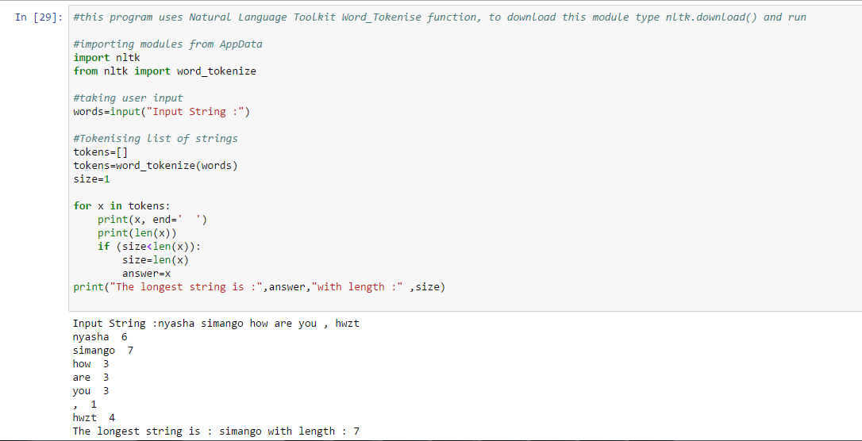

**Source Code**

#this program uses Natural Language Toolkit Word_Tokenise function, to download this module type nltk.download() and run

#importing modules from AppData

import nltk

from nltk import word_tokenize

#taking user input

words=input("Input String :")

#Tokenising list of strings

tokens=[]

tokens=word_tokenize(words)

size=1

for x in tokens:

print(x, end=' ')

print(len(x))

if (size<len(x)):

size=len(x)

answer=x

print("The longest string is :",answer,"with length :" ,size)

**Conclusion**

The program could take up list of words print length of each word then return the longest word from the list of words.